Assignment 5: Interference

- Two speakers are placed in a line, facing each other. Brianna hears a loud spot in the center. She then moves her from the center at distance of 0.25 meters, where she hears a second loud spot.
  - What is the difference is distances from the speakers to her ear?

  - What is the wavelength of the sound wave?

  - The speed of sound is 343 m/s. What is the frequency of the sound wave?

- Erin places two speakers in a horizontal line, 4 meters apart. She stands next to one speaker and begins to walk away from it, perpendicular to the line of the speakers. Seven meters away, she finds the first loud spot.
  - What is the wavelength of the sound wave?

  - The speed of sound is 343 m/s. What is the frequency that the speakers are producing?

A

B C
- You are standing at point A of the square shown to the right. At points B and C there are two speakers. While standing at point A, you hear loud sound due to constructive interference between the speakers. As you walk along the edge of the square toward the top, right corner, you hear the sound gradually get softer, then get louder again until it is loudest at the corner of the square. If the square is 4.6 meters on each side, what is the wavelength of the sound waves?

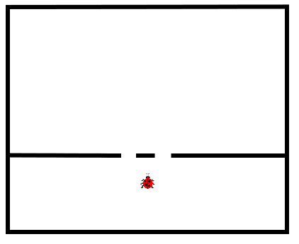
- A bug falls in a pool of water that has a divider in it, as shown in the picture. The distance between the two openings is 7 cm. The distance from the divider to the far wall is 35 cm. As the bug swims, it makes waves that travel at a speed of 2 m/s, and have a frequency of 22 Hz.
  - What is the wavelength of the waves made by the bug?

  - Sketch the shape of the waves that the bug makes. Include the waves that pass through the openings in the barrier.

  - Of the waves that hit the far wall, the largest ones occur at the center. How far from the center is the first region of smallest waves?

  - How far from the center is the region of next-largest waves?

- A laser has a wavelength of 6.3 x 10⁻⁷ m. It shines on a piece of metal with two small holes drilled in it. The separation of the holes is 1 x 10⁻⁴ m. A screen is placed 3 meters away. What is the distance from the central bright spot to the third-order bright spot?

